**Lab 12 - Advanced Terrain Analysis**

**Learning Objective**

In this lab we’ll cover a variety of terrain analysis techniques including shelter analysis and a suite of tools within the hydrology toolbox.

**What you need to submit**

**Lab 12: Answer Sheet**  
Name:

**Part 1**  
**Question 1**:  
What is the value of the majority of the cells on the focalcells raster layer?

Where are the cells with smaller values located?

and why do they have smaller values?

**Question 2**:  
What is the value range in the shelter analysis raster layer? ________ to ________

A large positive value means:

A value close to zero means:

A small negative value means:

**Question 3**:  
What is the interpretation of the sinks output? What would the correct symbology of this layer look like?

**Question 4**:  
Paste your final unit hydrograph here.

# ****Materials****

|  |  |  |
| --- | --- | --- |
| Relevant part | Data Name | Description |
| Part01 | chase_dem | DEM for Chase County, KS (30m cell size, elevation in feet) |
| Part02 | Pour_point | A point feature layer that depicts the outlet downstream of the Little River where you'll create a unit hydrograph. |
| Part02 | Stowe_boundary | A polygon feature layer that depicts the boundaries of Stowe, Vermont. This layer was derived from data available from [Vermont Center for Geographic Information (VCGI)](https://vcgi.vermont.gov/) |
| Part02 | Stowe_DEM | A raster layer that depicts elevation within the study area. It also has a resolution of 30 meters. It was derived from data made available by the [United States Geological Survey (USGS)](https://www.usgs.gov/). |
| Part02_worked | Stowe hydrology folder | A worked version of part 2 in consideration of processing power |

This lab, and part 2 in particular, can take a while when CPU is a limiting concern. I can offer a few suggestions, and an alternative.

* Pick a smaller area to process.
* You can skip step if you are careful, as outlined in the instructions.
* If you pause drawing that may speed up UI interactions
* When not actively manipulation the tools you can multi-task. Take the time to understand the workflow, fire off a process, and move onto something else. Try not to have anything super intensive running in conjunction, but light Microsoft office work shouldn’t break you.
* As a stopgap if it’s taking too long, I have provided a copy of my part 2 for you to look over. Use this only if needed.
* [A great album to jam to while working](https://open.spotify.com/album/1Un2hgy3OUsbmmFNop3Pj2?si=oYzFtULARyqAQVSG66_pdw).

# ****Part 1: Terrain Exposure Analysis****

In this part of the lab, we will perform a terrain exposure analysis, referred to as shelter analysis.

## **Terrain Exposure Analysis Procedure**

### **Project and normalize raster**

**1)** Start ArcGIS Pro and rename the data frame to Terrain Exposure Analysis. Because we are working at a relatively small geographic scale, we should first reproject our raster from it’s native projection (GSC_North_America_1983) to a more appropriate one for this analysis (NAD_1983_StatePlane_Colorado_South_FIPS_0503 WKID: 26955).

* Search for and navigate to  **Project Raster(Data Management)**
* For your Input raster select you *chase_dem* from your lab12\part01 folder using the browse button.
  + Here we use the browse button to avoid data locks on the elevation data and avoid inadvertently assigning a projection to the dataframe prematurely.
* Call the Output raster *proj_dem* saved in your lab12\part01 folder
* To select an Output coordinate system, and define the coordinate system as: 26955. Click OK.
* Set the Resampling technique to BILINEAR and click Run.

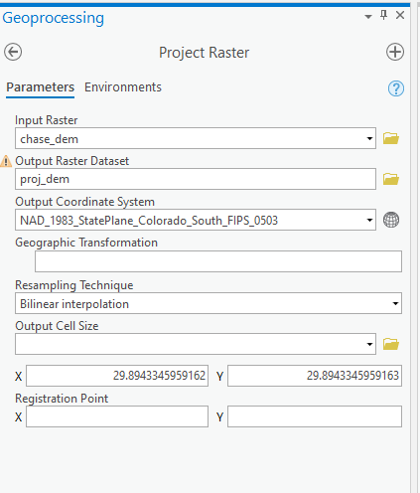

**2)** Finally, convert the elevation from feet to meters.

* Raster calculator expression: *proj_dem * 0.3048*
* Name the output *chase_m*

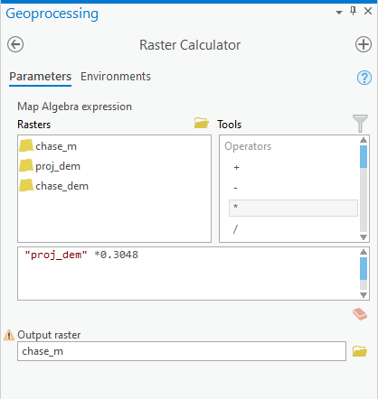

The map may look like this:

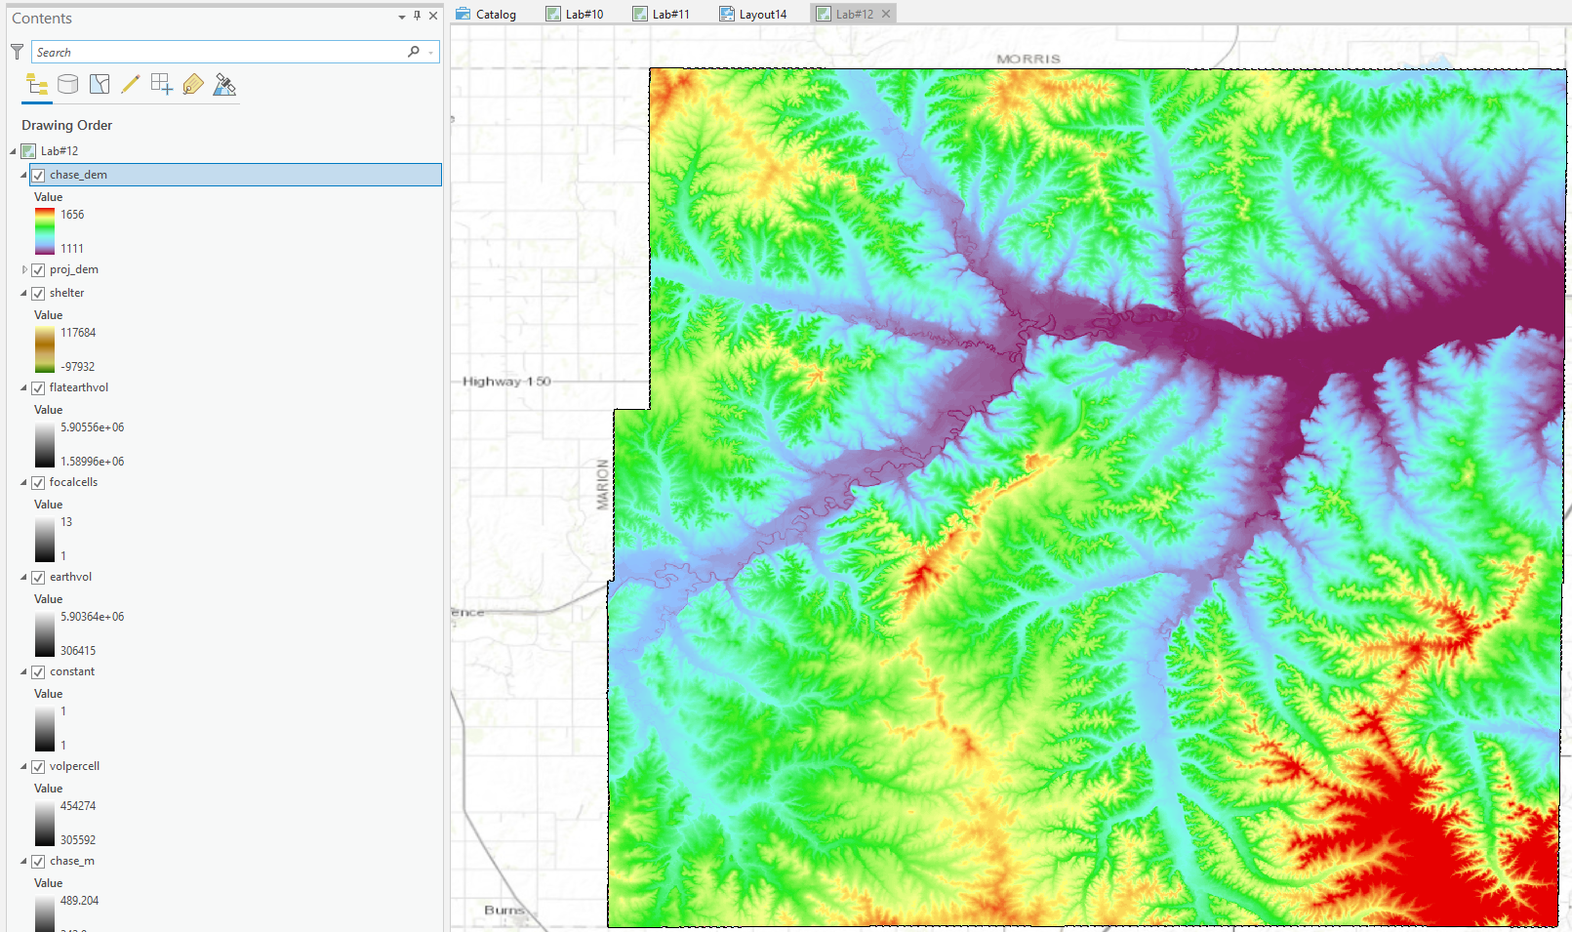

### **Calculate the volume of earth around a window**

**1)** First let’s calculate the volume of earth per cell.

* Raster calculator expression, we can round here:
  + *chase_m * 30 * 30*
* Call your output *volpercell*

**2)** Finally, use Focal Statistics to calculate the focal sum of this raster layer using a circular neighborhood with a radius of 2 cell size.

* Save the output raster layer as *earthvol*

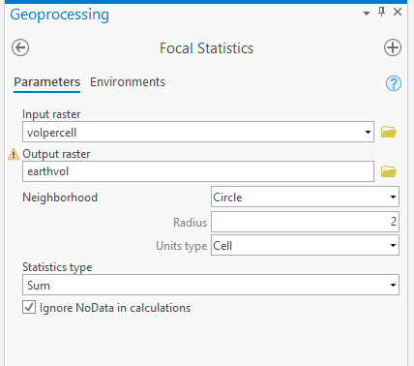

### **Calculate the earth volume of a cylinder of earth around a window**

**1)** Create a flat surface using **Raster Calculator** to create a constant raster layer on which all of the cells have a value of 1.

* *(“chase_m” / “chase_m”)* will do the trick.
* Make the output raster a permanent raster named *constant*

**2)** Use **Focal Statistics** to calculate the focal sum on the *constant* raster layer using a circular neighborhood with a radius of 2 cell size.

* Save the output raster layer as *focalcells*

**3)** Calculate the earth volume within the circular neighborhood assuming all the cells inside the neighborhood have the same Z value as the focus **(“volpercell” * “focalcells”)**

* Save the output raster layer as *flatearthvol*
* Answer question #1 on your assignment sheet

### **Calculate the shelter layer**

* Calculate the shelter raster layer by subtracting *flatearthvol* from *earthvol*
* Save the output raster layer as *shelter*

After some stylization, you might end up with a map that looks like so:

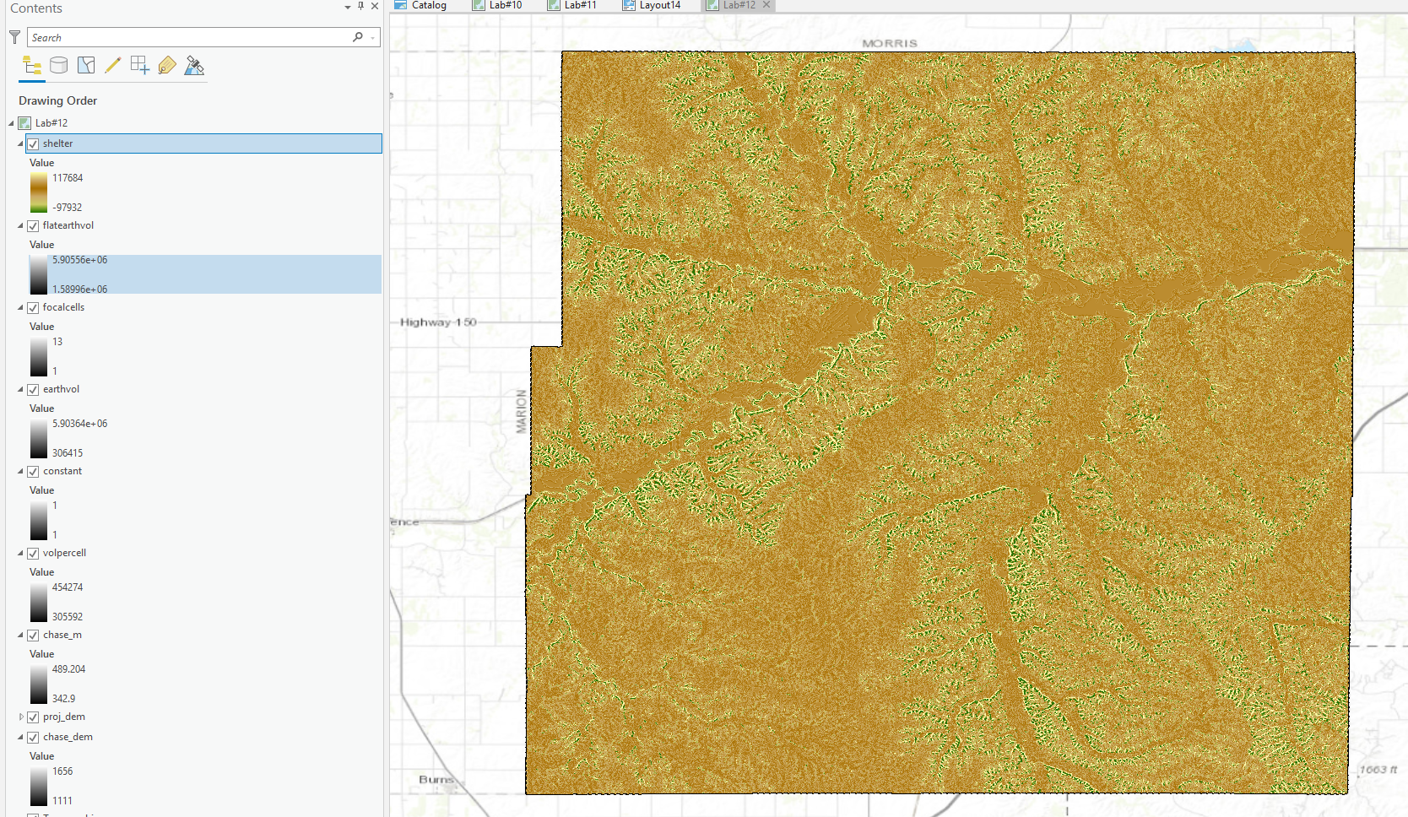

# ****Part 2: Creating a Unit Hydrograph****

The instructions herein are guided by material gratefully pilfered from [https://learn.arcgis.com/en/projects/predict-floods-with-unit-hydrograph](https://learn.arcgis.com/en/projects/predict-floods-with-unit-hydrographs/)

## **Precondition the elevation model**

Either import the Stowe_DEM and Pour_point or download and select your own pour point for this analysis.

### **Identify and Fill Sinks**

**1)** First, you’ll identify sinks in your DEM. Although your DEM was derived from reliable data provided by the USGS, sinks may still be present. In order to identify them we need to know which way the water flows over the surface. The first tool in the workflow is the **Flow Direction** tool.

* For Input surface raster, choose *Stowe_DEM*.
* save the output as *Stowe_flow_direction* in the geodatabase.

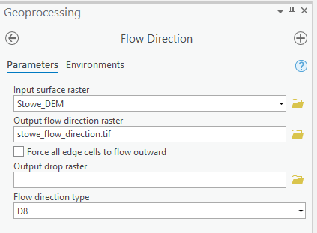

The symbology of the resulting layer corresponds to the direction water is likely to flow. The layer’s appearance isn’t important to this analysis, we just need this layer to run the next step…

**2)** Open the **sink tool**, the next step in the analysis.

* For Input D8 flow direction raster, choose *Stowe_flow_direction*.
* Save the output as *Stowe_sinks*.

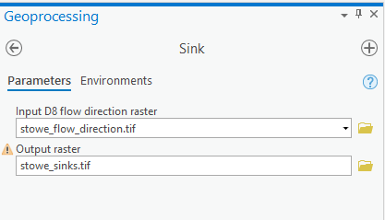

**3)** The final step in the current task uses the **Fill tool** to remove sinks from a DEM.

* For Input surface raster, choose Stowe_DEM
* Name the output *Stowe_fill*.

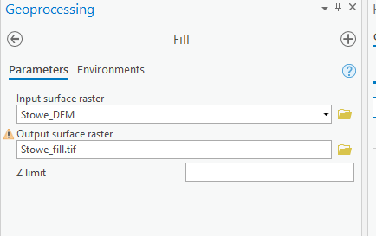

## **Delineate the Watershed**

Having now removed sinks from the DEM, it is considered “hydrologically conditioned” and is ready for hydrological analysis. We’ll use this DEM to determine the watershed area for the outlet point south of Stowe (or wherever you want to drop your point!). A watershed area is the area in which all flowing water will flow toward a certain point—in this case, your outlet. With the watershed area, you’ll be able to limit your subsequent analysis results to the relevant area for your outlet. Determining a watershed requires two components: a flow direction raster layer and an accurate outlet point. One of the most common reasons for a watershed analysis to fail is when the pour point is not adequately aligned to the flow grids. For that reason the **Snap Pour Point** tool is often included in a workflow. This step can be skipped if you are deliberate with your placement of the point, but I’ll walk through the workflow using it here. First, you’ll determine the stream’s exact location by calculating the areas where water accumulates the most. Then, you’ll snap the outlet point’s location to match the stream and verify it.

### **Assess flow directions**

The first step to delineate a watershed is to determine the direction that water will flow in your DEM. That way, you can determine the areas where water will flow to the outlet. To do so, you’ll…

**1)** Create another **flow direction** raster layer, this time for your DEM with filled sinks.

* For Input surface raster, choose *Stowe_fill*.
* Name your output *Stowe_fill_flow_direction*.

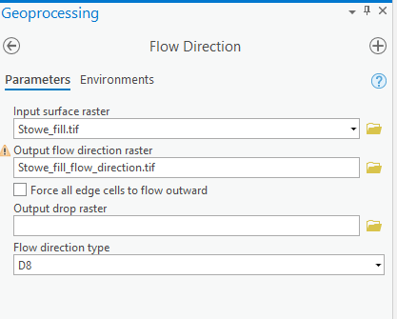

### **Snap outlet to stream**

**2)** Open the **Flow Accumulation tool**. This tool creates a raster layer that indicates where water is most likely to accumulate. The flow accumulation for each cell is expressed as a numeric value based on the number of cells that flow into that cell. Cells with high values of accumulation often coincide with the locations of flowing water bodies. With your flow accumulation raster, you’ll identify the Little River that flows through Stowe.

* For your Input flow direction raster, choose *Stowe_fill_flow_direction*.
* Name your Output accumulation raster *Stowe_flow_accumulation*.
* You’ll leave the remaining parameters unchanged. The first of these parameters applies a weight to each cell, which is useful when you expect water to be distributed in ways that aren’t uniform (for instance, in larger study areas where precipitation levels may vary significantly). The second parameter determines whether accumulation will be measured with integers or floating points. Floating point, the default value, allows for the inclusion of decimal places, making it more accurate in most situations. The third parameter determines the input flow direction.

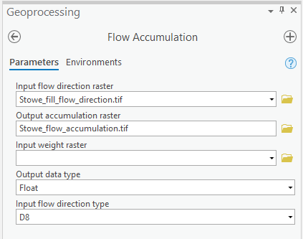

The next step of the task opens the Measure Distance tool (which is a tool on the ribbon, not a geoprocessing tool). You’ll use this tool to measure the distance between the current outlet point and the Little River’s location as represented in the flow accumulation raster. You can use this distance to then snap the outlet point to the correct cell so that it precisely lines up with the stream. Be sure you’re as precise as feasible by zooming in closer to the outlet point. click the outlet point. Then double-click the approximate center of the nearest cell with a high flow accumulation value. The Measure Distance tool’s window updates to include the length of the measurement. I measurement approximately 50 meters so I’ll round to a distance of 60 meters when I snap the outlet point to the stream. A snapping distance that is slightly higher than the measured distance will help avoid ambiguity in the tool. When deciding on a snapping distance, be sure it doesn’t exceed the measured distance by too much, or the point may snap to an area further downstream.

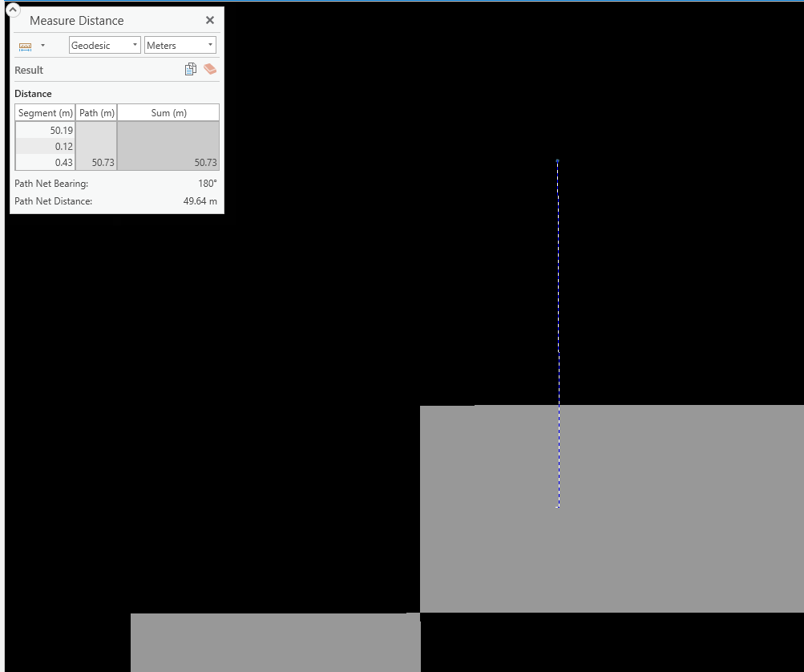

**3)** Open up the **Snap Pour Point** tool.

* For Input raster or feature pour point data, choose *Pour_point*.
* For Input accumulation raster, choose *Stowe_flow_accumulation*.
* Name the output raster *Stowe_snapped_outlet*.
* For Snap distance, type 60.

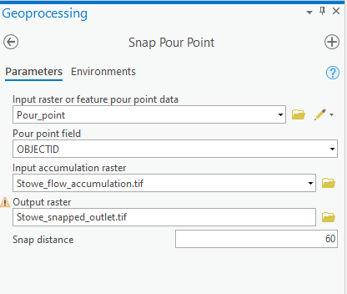

The tool runs and the snapped outlet raster layer is added to the map. The raster displays a single cell that represents the outlet’s new location. In the example image, the snapped outlet is represented as a yellow cell.

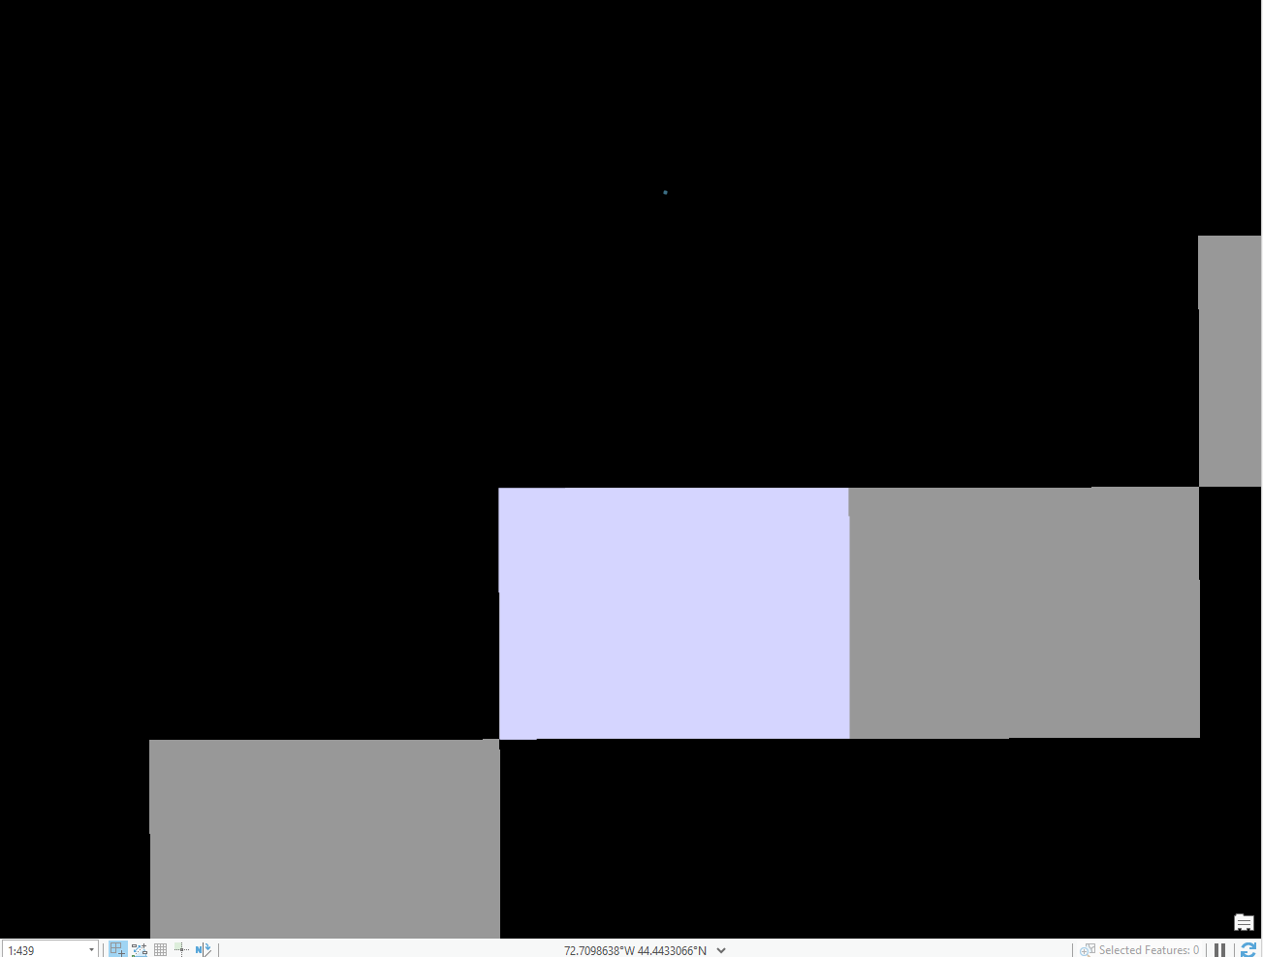

### **Delineate watershed upstream of outlet**

Now that you have both a flow direction layer and an accurate outlet layer, you can determine the watershed area upstream of the outlet.  
**4)** The final step of the task opens the **Watershed tool**.

* For Input D8 flow direction raster, choose *Stowe_fill_flow_direction*.
* For Input raster or feature pour point data, choose *Stowe_snapped_outlet*.
* For Output raster, set the name to *Stowe_watershed*.

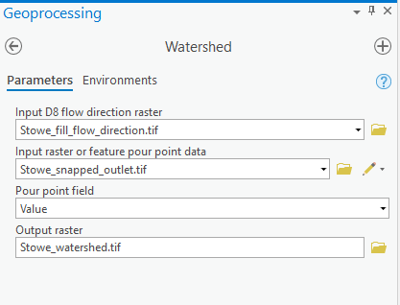

## **Create a velocity field**

Next, you’ll start determining how long it takes water to reach the outlet, allowing the town to better predict when flooding will occur during a hypothetical rainfall event. To determine the time it takes water to flow somewhere, you first need to determine how fast water flows. You’ll calculate the speed of flowing water with a velocity field, another type of raster layer. There are many types of velocity fields, and they can be calculated with a wide variety of mathematical equations. You’ll create a velocity field that is spatially variant, but time and discharge invariant. This means that your velocity field makes the following assumptions:

* Velocity is affected by spatial components such as slope and flow accumulation (spatially variant).
* Velocity at a given location does not change over time (time invariant).
* Velocity at a given location does not depend on the location’s rate of water flow (discharge invariant).

In reality, velocity could be time variant and would definitely be discharge variant. However, incorporating these variants would require additional datasets that might not be available and use modeling techniques that might not be replicable in a GIS environment. The spatially variant, time- and discharge-invariant velocity field will provide a generally accurate result, although it’s important to remember that any method will be only an approximation of observed phenomena. You’ll use a method for creating velocity fields first proposed by Maidment et al. (1996)[1](https://jimcoll.github.io/classes/geog558/labs/lab08/#fn:1). In this method, each cell in the velocity field is assigned a velocity based on the local slope and the upstream contributing area (the number of cells that flow into that cell, or flow accumulation). They use the following equation:

V = Vm * (sbAc) / (sbAcm)

Where:

* V is the velocity of a single cell with a local slope of s and an upstream contributing area of A.
* Coefficients b and c can be determined by calibration. In this scenario, you’ll use the method’s recommended value of b = c = 0.5.
* Vm is the average velocity of all cells in the watershed. You’ll assume an average velocity of Vm = 0.1 m/s.
* sbAcm is the average slope-area term throughout the watershed. To avoid results that are unrealistically fast or slow, you’ll set limits for minimum and maximum velocities. The lower limit will be 0.02 meters per second, while the upper limit will be 2 meters per second.

This equation is only one of many ways that a velocity field can be calculated, and it comes with several assumptions and limitations of its own.

### **Create the slope raster**

The primary variables in the equation you’ll use for your velocity field are slope and upstream contributing area. You already have a raster layer for upstream contributing area: the flow accumulation layer you created above, but we don’t yet have a slope layer, so that’s the next one we’ll create.  
**1)** Open the **Slope tool**.

* For the Input raster, choose *Stowe_DEM*
* Name your Output raster *Stowe_slope*

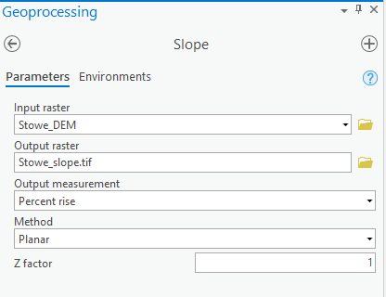

### **Calculate the slope-area term**

Now that we have a raster layer for both slope and flow accumulation area, we’ll calculate a new raster layer that combines them. This layer will show the slope-area term (the value sbAcm from the Maidment et al. equation).

**2)** The next step can be accomplished using the **Raster Calculator tool**.

* Use the fields to create the expression:  
  Power("Stowe_flow_accumulation",0.5) * Power("Stowe_slope",0.5)
* Name your output raster *Stowe_slope_area_term*.

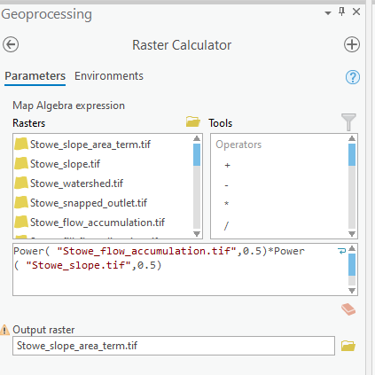

* Finally, lets use the environments of this tool to clip to our watershed at the same time: In the **Environments**. Under **Raster Analysis** for **Mask**, choose **Stowe_watershed**.

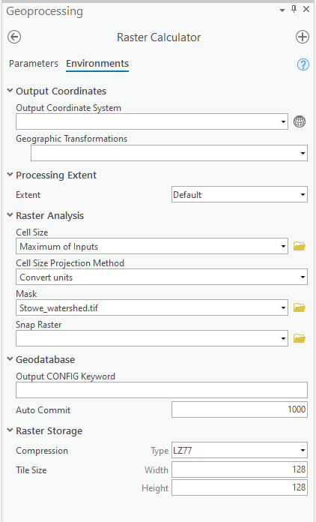

* Your output should look like so:

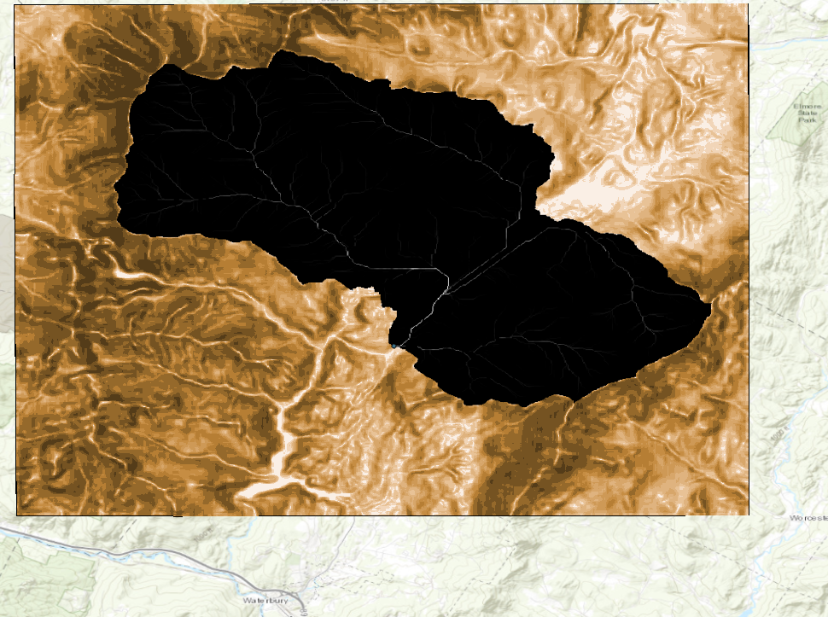

### **Calculate the velocity field**

**3)** Now that you have the slope-area term, you can calculate a velocity field using the following equation:

V = Vm * (sbAc) / (sbAcm)

As mentioned previously,

* Vm is the average velocity of all cells in the watershed. You’ll use an assumed average value of Vm = 0.1, which is recommended by Maidment et al.
* Similarly, sbAcm is the average slope-area term across the watershed. Because you’ve calculated slope-area term for the watershed, we can simply pull the median out of our raster. To find it you need to…

**3A)** right-click **Stowe_slope_area_term** and choose **Properties**, and under the **Source** tab and expand the **Statistics** heading.

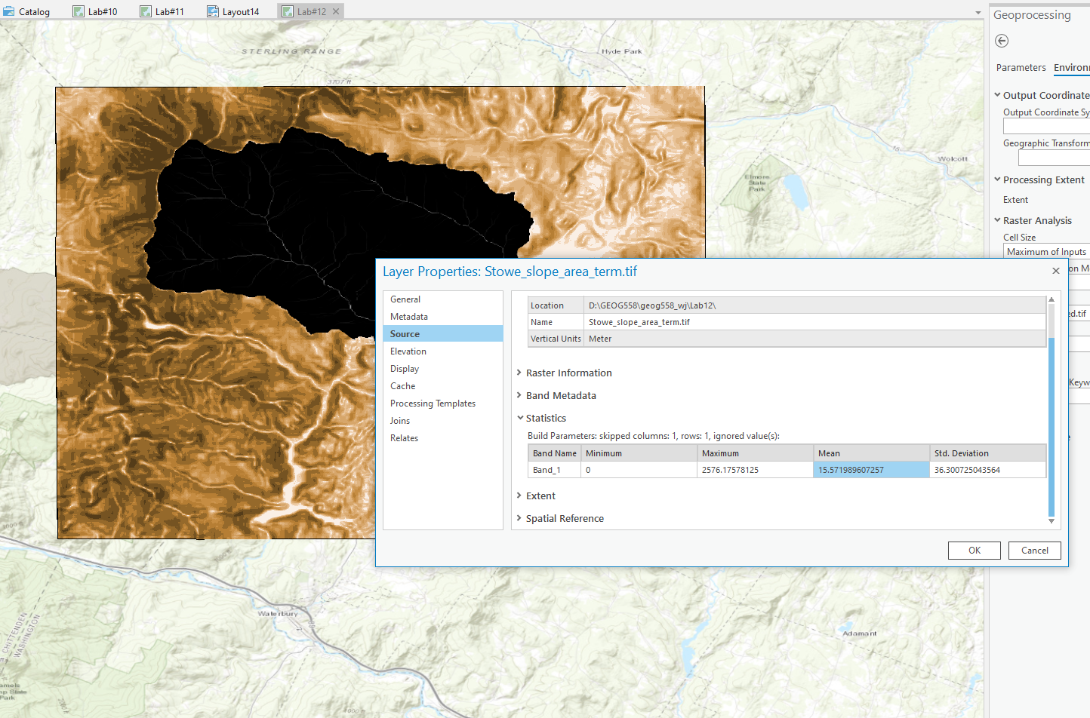

**3B)** and then open a **raster calculator** and enter the expression, Where **[Mean slope-area term]** is the value that you copied from the **Layer Properties** window:

* You expression should look like:  
  0.1 * ("Stowe_slope_area_term" / [Mean slope-area term])
* Call that output Stowe_velocity_unlimited

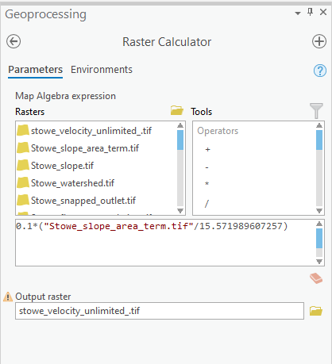

### **Limit the velocities**

The raster layer you created is a velocity field, but it has unrealistically high and low velocities. For instance, some values in the field have a velocity of 0 meters per second, which is unlikely during an extreme rainfall event. Likewise, the maximum value of approximately 7.5 meters per second is unrealistic even during a major flood. You’ll limit the velocity values with a lower limit of 0.02 meters per second and an upper limit of 2 meters per second. Bearing in mind that there are a number of ways to end up with the desired output, the most direct in my opinion is a [complex raster calculator con expression](https://desktop.arcgis.com/en/arcmap/latest/tools/spatial-analyst-toolbox/conditional-evaluation-with-con.htm). Other alternatives include reclassifying, multiple con tools, or a clamp tool to name a few.  
**4)** Open up a **Raster Calculator** and enter your expression.

* My expression looks like so:  
  Con("Stowe_velocity_unlimited" < 0.02,0.02,Con("Stowe_velocity_unlimited" > 2,2,"Stowe_velocity_unlimited"))
  + Read it from right to left: “If “Raster” is less than x, put y, otherwise; if “Raster” is greater than than w, put z, otherwise put “Raster””
* Save your output as *Stowe_velocity*.

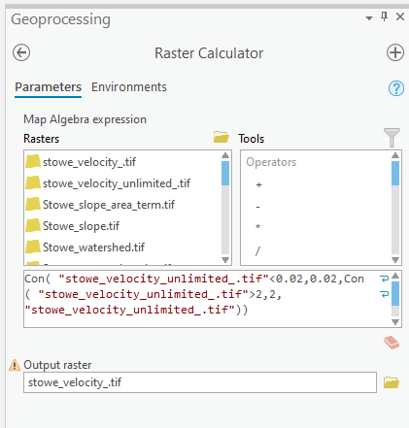

## **Create an isochrone map**

Having now created a velocity field that predicts how fast water will flow throughout Stowe, we still need to know the time it takes to get to the pour point. In this step we’ll create an isochrone map, which maps the time it takes to reach a specified location from anywhere else in an area. To create the isochrone map, you’ll first create a weight grid. Then, you’ll assess the time it takes for water to reach the outlet.

### **Create a weight grid**

Flow time is calculated with a relatively simple equation: The length that water must flow divided by the speed at which it flows. While you know how fast water flows due to your velocity field, you don’t know flow length. To determine flow length, you need two variables: flow direction (which you know) and weight (which you don’t). Weight, in regard to flow, represents impedance. For instance, water flowing through forested land takes longer than water flowing over smooth rock because it’s impeded by terrain. While calculating weight may seem difficult without detailed terrain data, we can simplify our model by assuming that this weight is the inverse of the velocity we calculated. This is more formally notated as

Weight [L-1T] = 1 / Velocity [LT-1]

**1)** Thus, it is a simple matter to create our weights grid with a **raster calculator**.

* The raster calculator expression is:  
  1 / "Stowe_velocity"
* Save the output as *Stowe_weight*

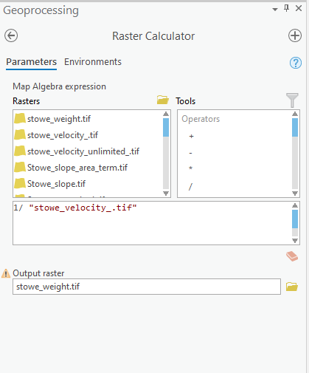

Your output should be like:

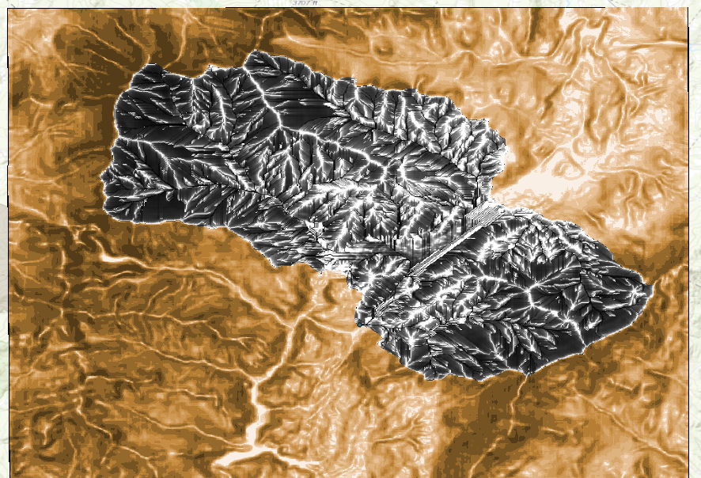

### **Assess flow time to outlet pour point**

**2)** The next step of the task uses the **Flow Length** tool. While this tool, as its name suggests, normally calculates flow length, it has an optional parameter to include a weight raster. When a weight raster is included, the tool calculates flow time instead.

* For Input flow direction raster, choose *Stowe_fill_flow_direction*.
* For Output raster, name it *Stowe_time*.
* For Direction of measurement, confirm that *Downstream* is chosen.
* For Input weight raster, choose *Stowe_weight*.
* Finally, use the **environments** of the tool to clip to our watershed at the same time again.

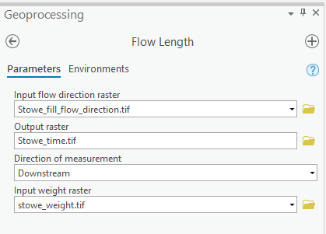

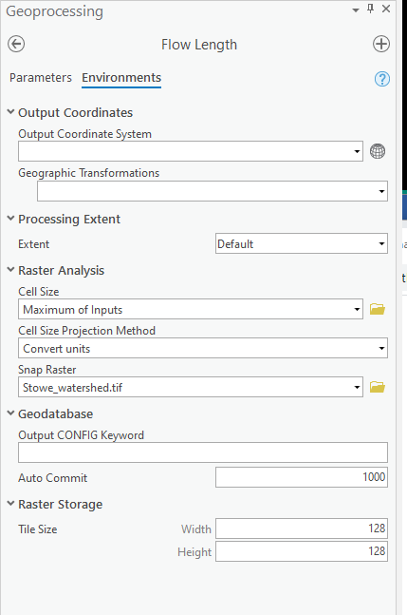

* Your output should look like so.

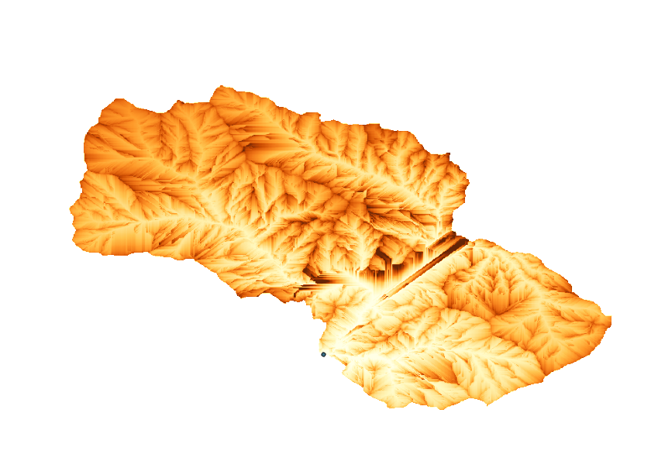

## **Create a unit hydrograph**

The last step we want to accomplish is to create a unit hydrograph. In essence, this unit hydrograph is the area that falls within the specific we want the histogram of the output layer. Although conceptually simple, this can be quite difficult, as outlined in the source tutorial. Fortunately, simpler solutions exists, and the exact method will vary depending on your desired output. Here I will show how to create a “raw” unit hydrograph and manipulate it within ArcGIS Pro.

### **Approach 1) Visualize a “raw” unit hydrograph histogram and then Extract to create the desired output**

We will first…  
**1)** Cast the raster to an int. Because our unit is seconds, truncating our numbers is a reasonable tradeoff, and has the added benefit of creating a workable attribute table for us to export. Search for and open Int(Spatial Analyst)

* The input raster is *Stowe_time*
* Save the output as *Stowe_time_int*

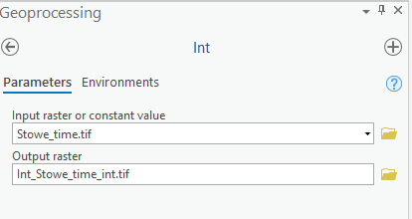

**2)** Export our results. We can export the raster as a table and use another software package to make a graph, or we can use ArcGIS’s built in graph maker to create a simple graph.  
**2A)** Open the attribute table. Go to Raster Layer > Data > Create Chart > Bar Chart. A Chart Properties will pop up.   
**2B)** Set the axis value and titles of x,y axis.   
**2C)** Export the image   
Attach your final graph to the report.

